THEORY QUESTIONS

PART I

MAP SKILLS AND THE ENVIRONMENT
1.
Use the map of Cham District to answer Question 1
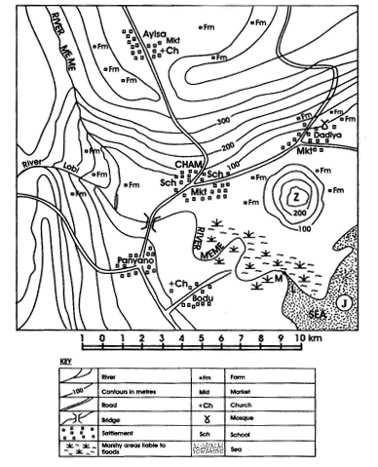
a)

i)

Contour intervals in metres
ii)

Direction of Dadiya from Panyano
iii)

Distance by road from the road junction of Panyano to the road junction to Cham
iv)

Direction of flow River Meme
b)

Name the features marked M, L, J and Z
c)

i)

What type of settlement is Dadiya?
ii)

Name any two crops which will grow well in the swampy areas of the map.

2.
a)

Name three types of rainfall
b)

With the help of a diagram describe how any one type of rainfall is formed.

PART II

NATIONAL COMMUNITY
3.
a)

Name the three arms of Government
b)

State two functions of each of the three arms of Government
c)

Mention four sources of revenue for the district assemblies in Ghana.

4.
a)

Name four plantation farms and their locations in Ghana.
b)

State four effects of plantation farming in Ghana

PART III

WEST AFRICA, AFRICA AND THE WORLD
5.
a)

State any four aims of the United Nations Organization
b)

Explain two problems facing the United Nations Organization

6.
What five major problems face the Economic Community of West African States (ECOWAS)?

